## **Slack API Send Message Step 1:-** *Create an classic App & Get Oauth Token*

* *Visit* [*https://api.slack.com/apps?new_classic_app=1*](https://api.slack.com/apps?new_classic_app=1)
* Choose **workspace** in which you want to send messages while creating App

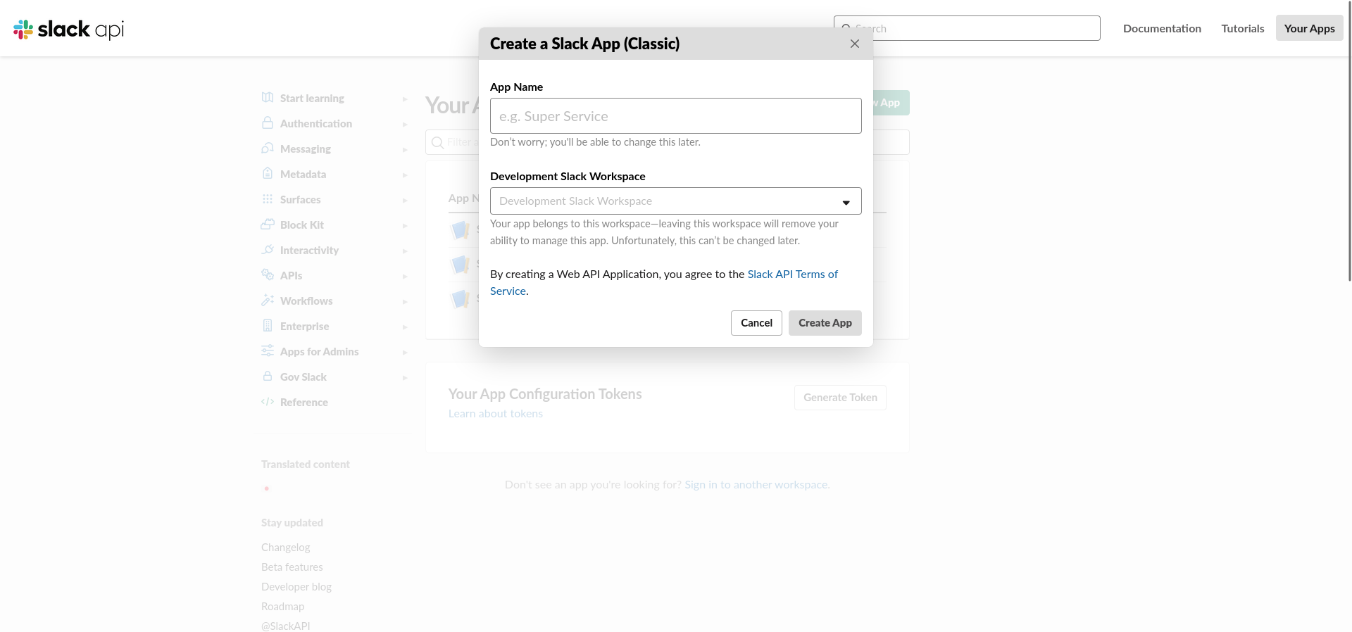

* Under Basic information > **Add features and functionality > Permissions > Find Scopes section and add permission**

[chat:write:bot](https://api.slack.com/scopes/chat:write:bot)

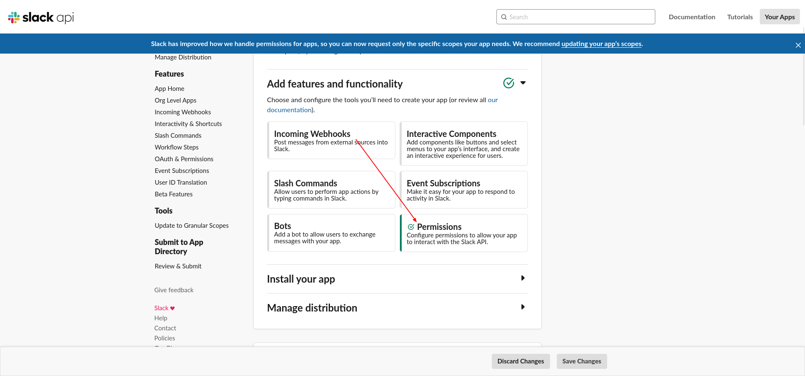

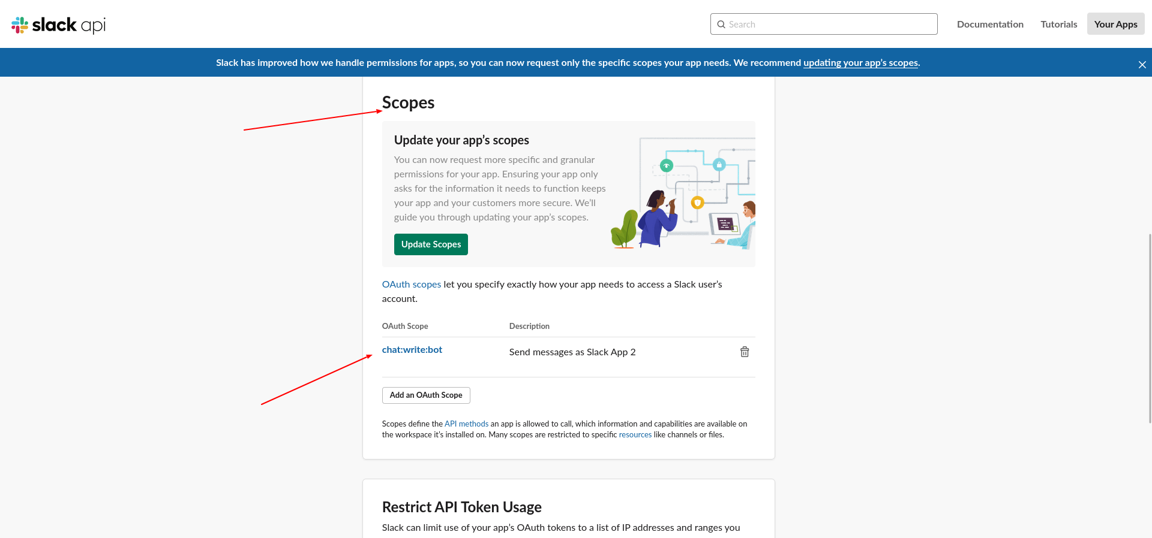

* Install Apps  
  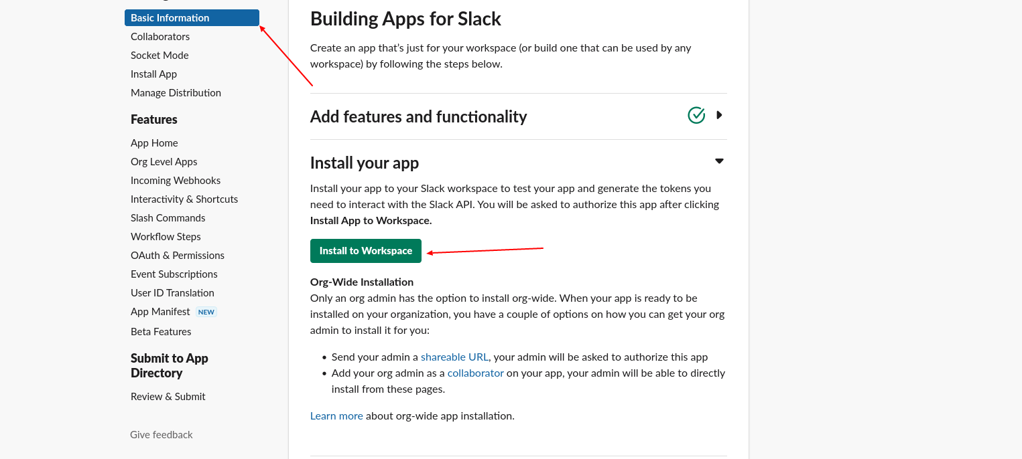
* Install Apps > Select Channel

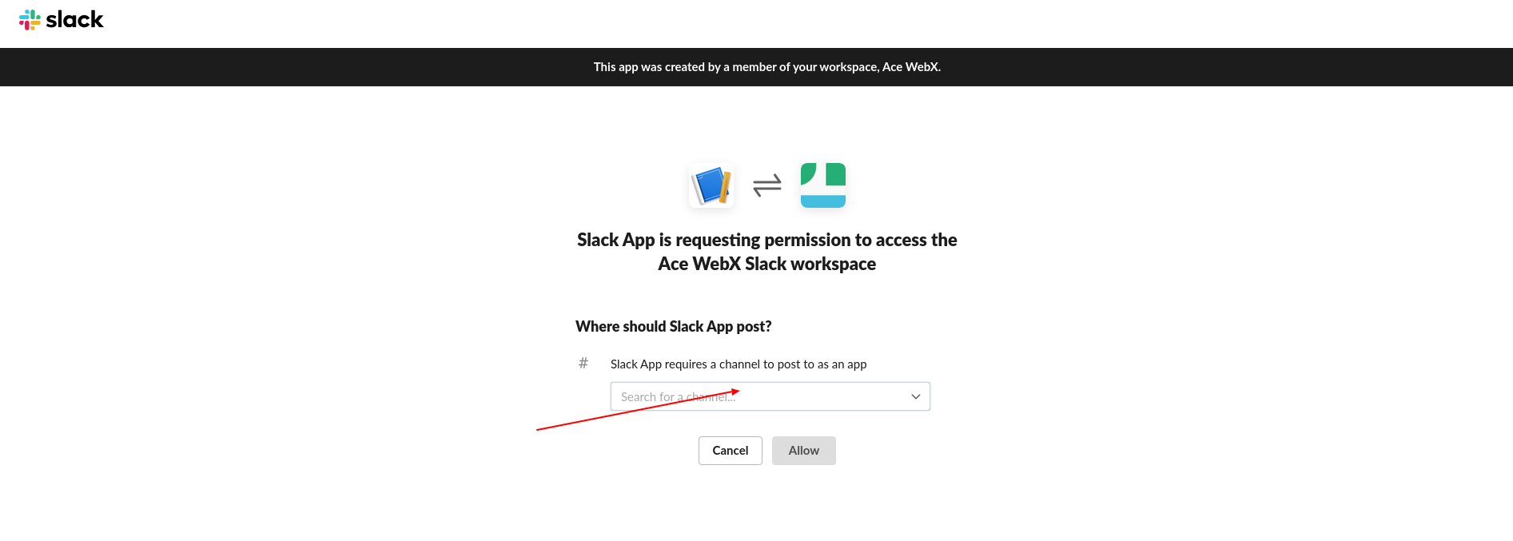

* Sidebar > **Oauth & Permissions***You will get Oauth Token from here*
* 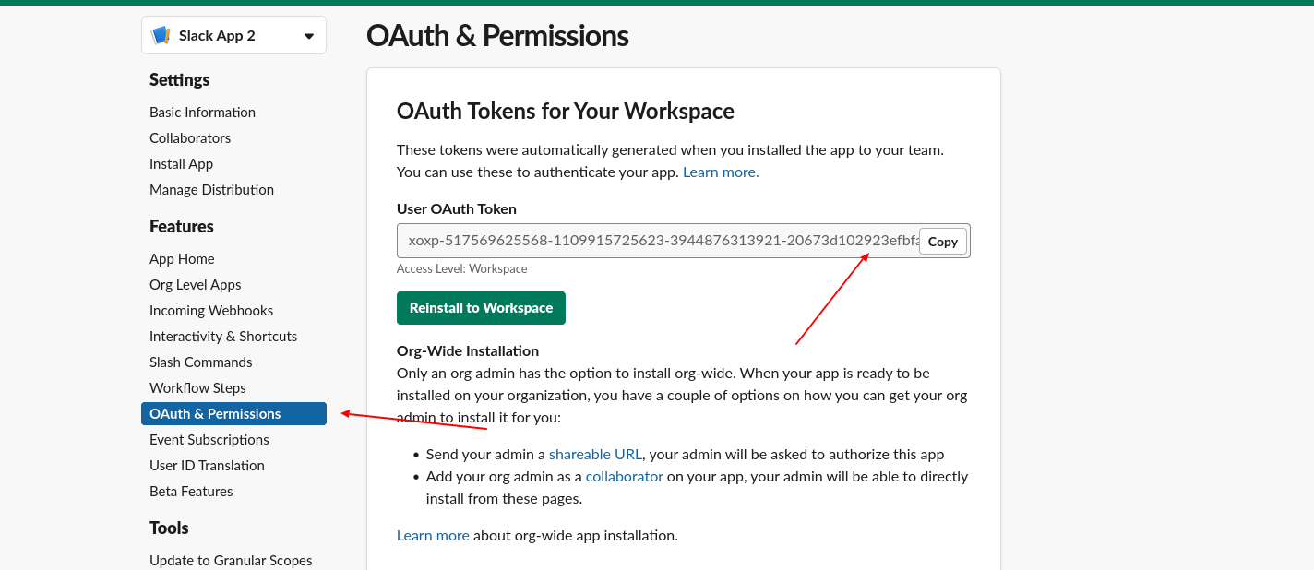

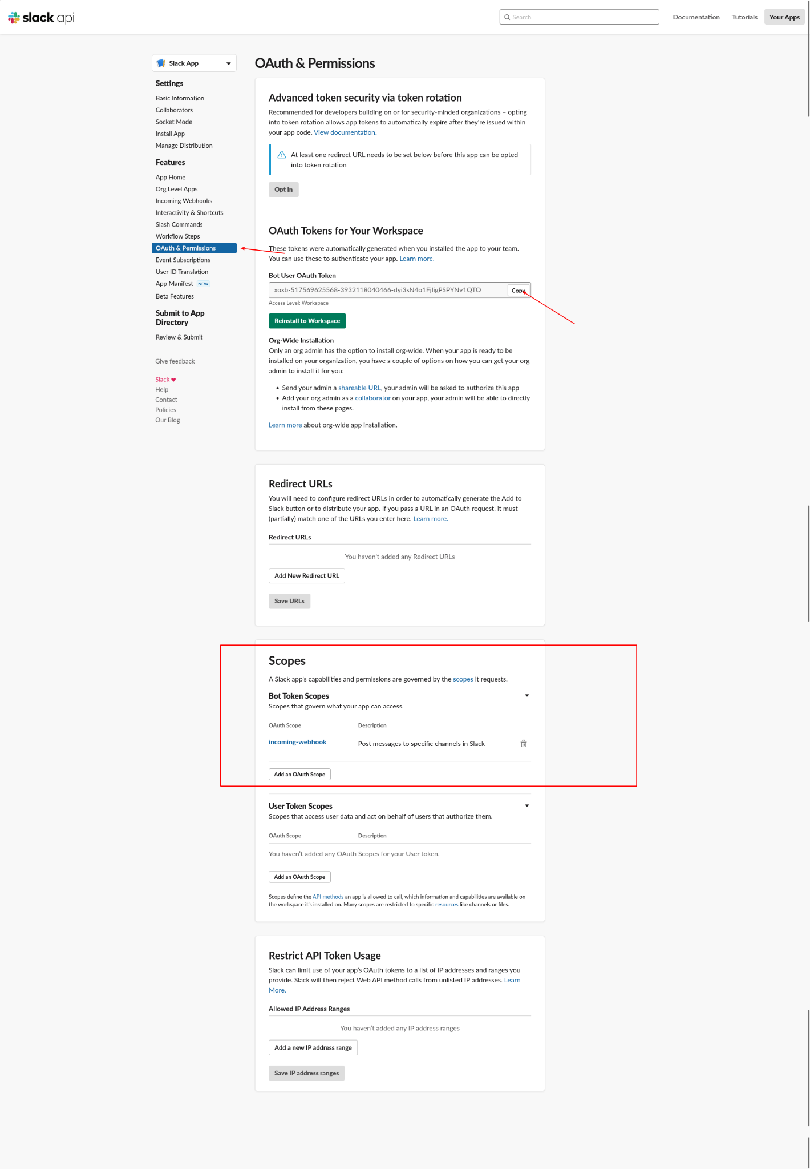

## Step 2:-

* We need Channel ID where in which you want send messages
* You will find it here in channel settings or alternate channel name

